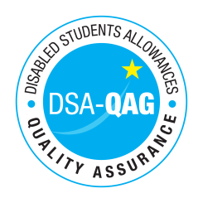
Insert Provider Name – PERFECT WORDS, BY AMANDA GEORGE, www.amandageorge.co.uk

Period covered - 01/04/2017 through to 31/03/2018

The table below shows NMH rates. The greyed out cells indicate that the NMH provider does not offer these services.

Note: NMH Support Rates shown per hour in the table below.
 | Standard Rate (in-person) |  |  | Distance Learning only (in-person, in-home |  |  | Remote Delivery (e.g. Facetime/Skype or similar) Only
Band 1 Support Assistants | Net | VAT | Total | Net | VAT | Total | Net | VAT | Total
Proof Reader / text checker |  |  |  |  |  |  | £20 per hour | N/A | £20 per hour
*Please delete any rows where you do not provide this support role

